A

Project Report on

**The Furniture Shop**

Developed By

**Kuvaradiya Keyur**

T.Y.B.C.A-5th Sem

Roll No :- 35

Submitted To

**Geetanjali College Of Computer Science & Commerce(BBA)**

**Saurashtra University, Rajkot**

[2019]

Guide Name

[Pro. Hardik Chavda]

**College Certificate**

**Acknowledgement**

* I am Greatly Appreciated Cooperation of Student, Teachers of Geetanjali College. The All Are For Very Supported.
* The Successful Completion Of A Project Is Generally Not A Individual Effort. It Is An Outcome Of The Cumulative Effort Of Number Of Persons, Each Having Its Own Importance.
* First I Would Like To Thanks Head Of Department Prof. Brijesh Shah And Project Guide Prof. Hardik Chavda.
* All Faculties Members  Providing A Valuable Guidance. Which Solved Our Difficulty.
* I am Highly Thank Full To All Members In Project Development And Thanks Full To All Our Friends And Family.

Thank You

**Kuvaradiya Keyur**

**PREFACE**

* The Furniture shop software is used to save client’s data easily.
* With the use of this software paperwork is going less.
* The furniture shop project is simple but important database system which can be used for sale furniture items.
* As one of the subject BCA it is very necessary for the students to prepare a project on any particular subject.
* we are prepared our project in C#.net as front End Microsoft SQL server as a back end language.

**INDEX**

|  |  |  |
| --- | --- | --- |
| **No** | **Topic Name** | **Page No** |
| **1** | **Project Profile** | **6** |
| **2** | **Project Requirement** | **7** |
| **3** | **Technology Requirement** | **8** |
| **4** | **Data Dictionary** | **9** |
| **5** | **Er Diagrams** | **12** |
| **6** | **Data Flow Diagram** | **14** |
| **7** | **Screenshots** | **16** |
| **8** | **Future Requirements Of Projects** | **28** |
| **9** | **Limitations Of Project** | **29** |
| **10** | **Bibliography** | **30** |

**Project Profile**

* **Project Title :-** The Furniture Shop
* **Operating System :-** Microsoft Windows 7
* **Front End Tool :**- C#.Net
* **Back End Tool :-** SQL Server 2012
* **Academic Year :-** 2019-2020
* **Developed By :- Kuvaradiya Keyur**
* **Guided By: -**Pro. Hardik Chavda
* **Submitted To :- Geetanjali College Of Computer Science & Commerce(BBA)**
* **Aim Of Project :**- Reduce man power and less paperwork

**Project Requirements**

**Software Requirements:-**

|  |  |
| --- | --- |
| Tools | Configuration |
| Platform | Windows |
| OS | Windows 7 On Words |
| Front End Tool | C#.Net |
| Back End Tool | Microsoft SQL Server 2012 |

**Technology Requirement**

1. **Hardware Requirement :-**

|  |  |
| --- | --- |
| Tools | Configuration |
| Processor | Intel Dual Core |
| RAM | 2 GB |
| Hard Disk | 500 GB or More |

1. **Software Requirement :-**

|  |  |
| --- | --- |
| Tools | Configuration |
| Platform | Windows |
| OS | Windows 7 On Words |
| Front End Tool | C#.Net |
| Back End Tool | Microsoft SQL Server 2012 |

**Data Dictionary Tables**

* **Table Name: -add item**

|  |  |  |
| --- | --- | --- |
| Field Name | Data Type | Constraint |
| Id | int | Auto Increment |
| name | varchar(20) | Not null |
| size | varchar(20) | Not null |
| price | varchar(30) | Not null |

* **Table Name: -add item**

|  |  |  |
| --- | --- | --- |
| Field Name | Data Type | Constraint |
| Id | int | Auto Increment |
| pname | varchar(20) | Not null |
| size | varchar(20) | Not null |
| price | varchar(20) | Not null |
| qty | varchar(20) | Not null |
| total | varchar(20) | Not null |

* **Table Name: -bill table**

|  |  |  |
| --- | --- | --- |
| Field Name | Data Type | Constraint |
| id | int | Auto Increment |
| name | varchar(20) | Not null |
| Size | varchar(20) | Not null |
| price | varchar(20) | Not null |
| date | varchar(20) | Not null |

* **Table Name: - customer detail**

|  |  |  |
| --- | --- | --- |
| Field Name | Data Type | Constraint |
| id | int | Auto Increment |
| name | varchar(50) | Not null |
| mno | varchar(20) | Not null |
| address | varchar(20) | Not null |
| date | varchar(20) | Not null |

**Entity Relationship Diagram**

ADD ITEM

add product

ADD PRODUCT

make bill

BILL TABLE

add customer detail & print bill

CUSTOMER DETAIL

**Data Flow Diagram**

* **Level - 0(Context Level):-**

USER

MAIN FORM

**Level - 1:-**

TV Unit Designs

Bed Design

LEVEL-1

Tipoi Designs

Sofa Design

Wardboard design

Wall Designs

Dining sets

Study Tables

Temple Design

Exit

**Screen Shots**

* **Main Form-**

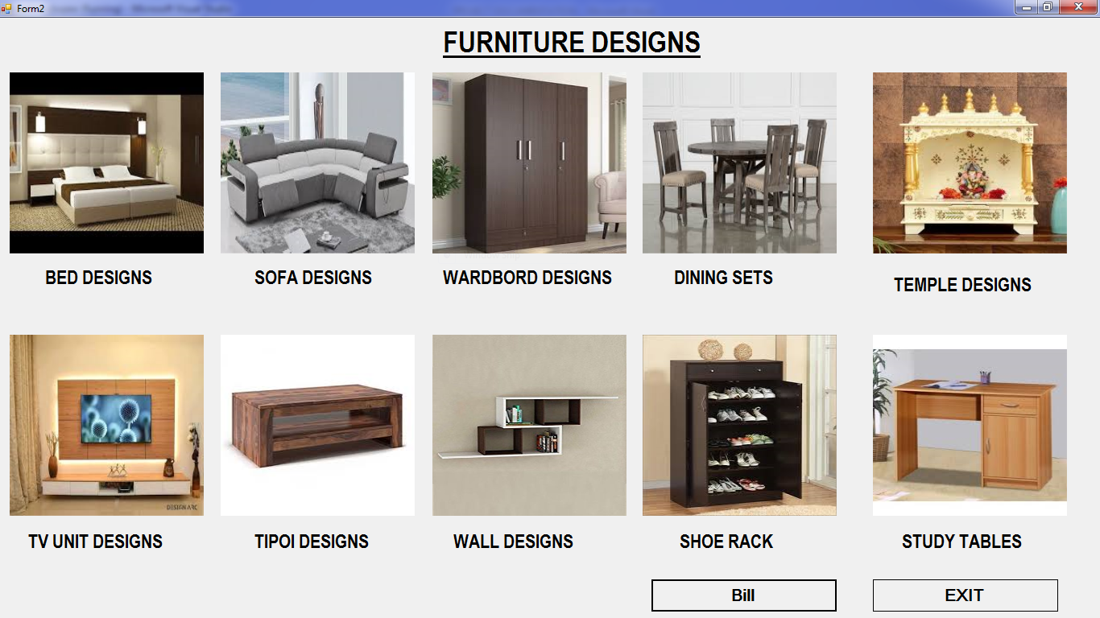

* This is main form.
* All furniture designs are included in this form.
* There are 9 different types of furniture designs.
* If you click on image of any furniture design picture you will get in that page.
* **Bed Designs-**

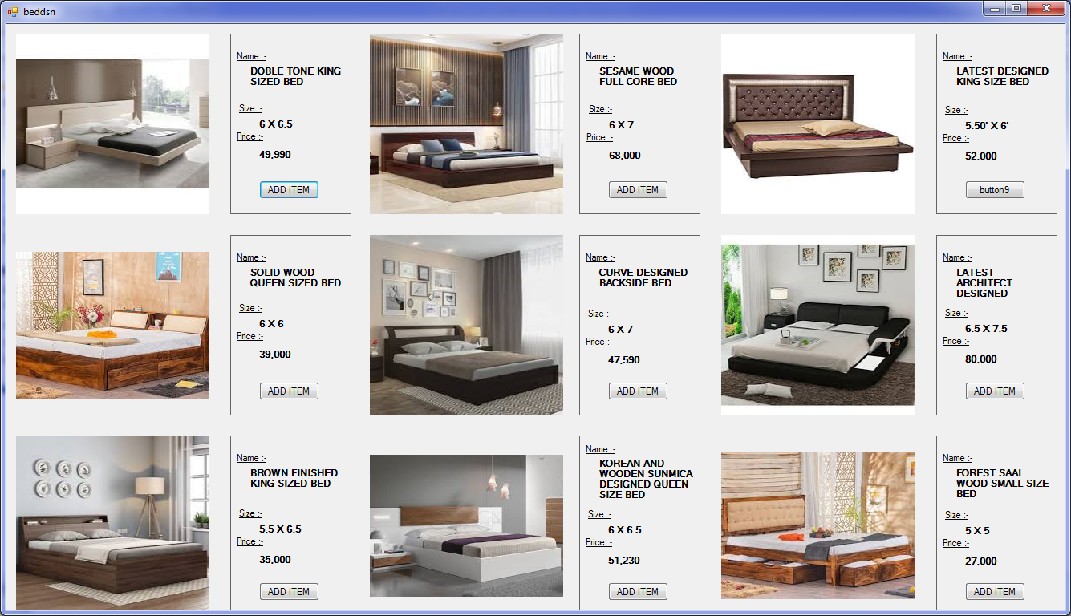

* This is Bed design form.
* There are 9 different designs of Bed.
* If you click on "ADD ITEM" , image will be added in the database.
* When you click on the "ADD ITEM" button button's name will be changed into "REMOVE".
* If you want to remove that item, item will be removed from the database.
* **Sofa Design-**

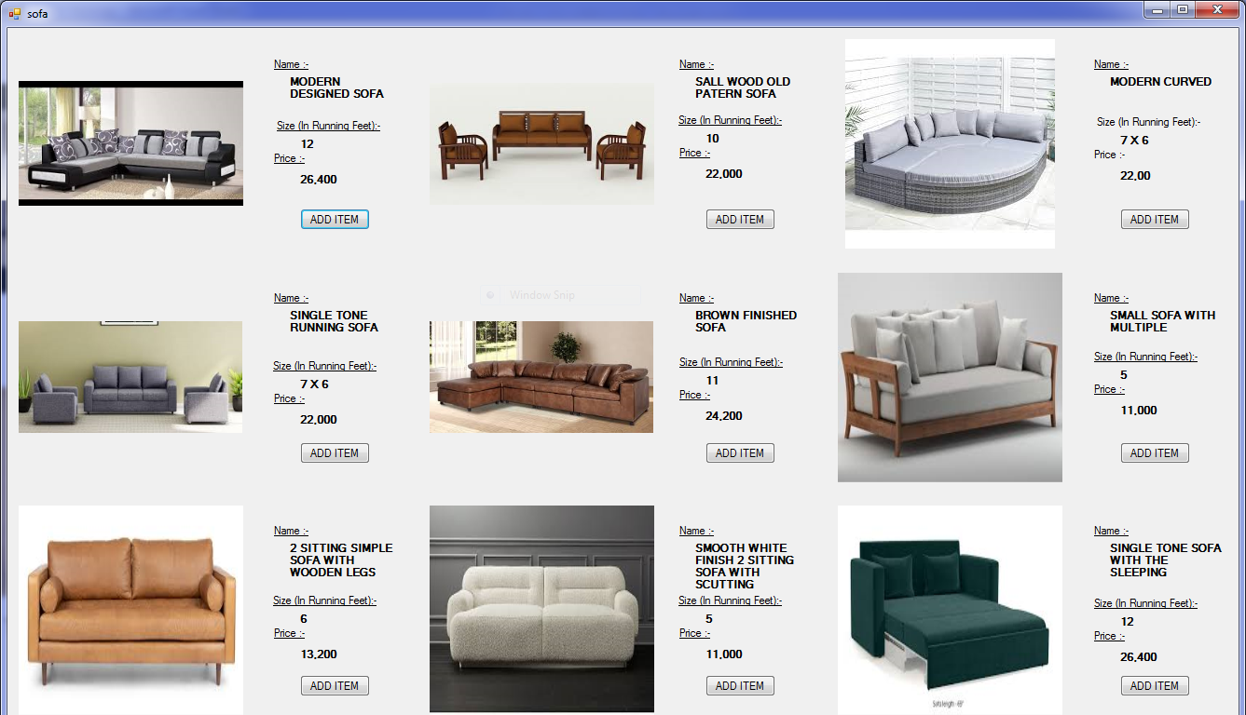

* This is Sofa design form.
* There are 9 different designs of Sofa.
* If you click on "ADD ITEM" , image will be added in the database.
* When you click on the "ADD ITEM" button button's name will be changed into "REMOVE".
* If you want to remove that item, item will be removed from the database.
* **Wardbord Design-**

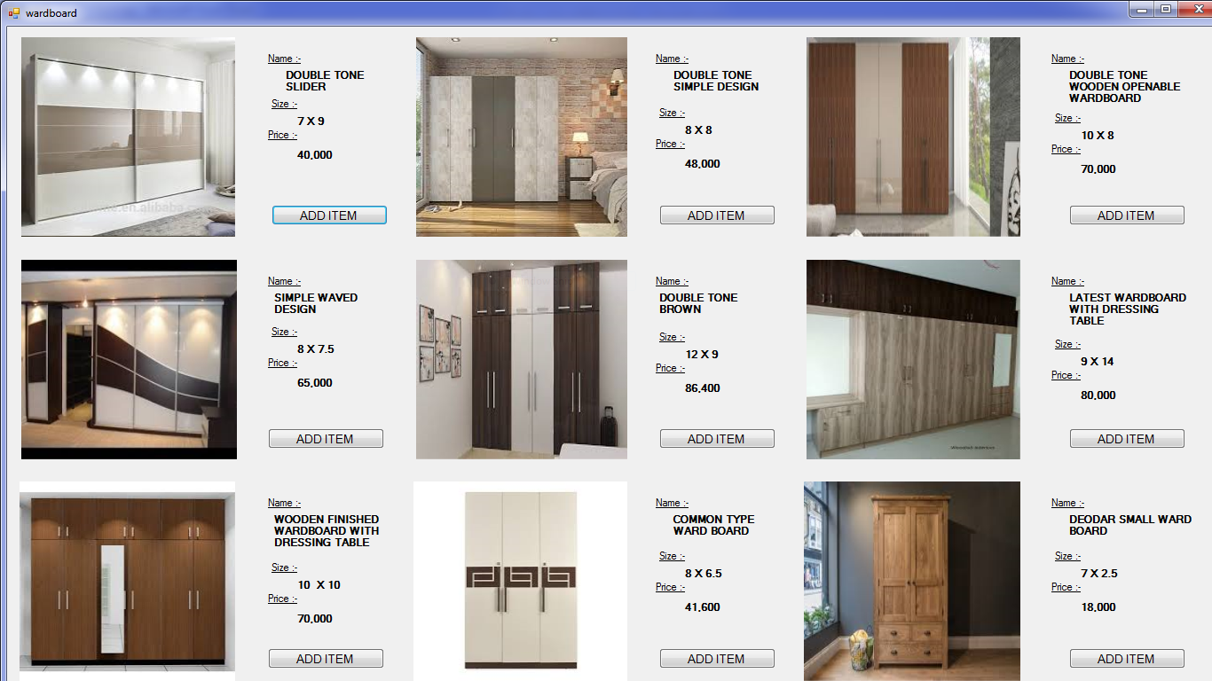

* This is Wardbord design form.
* There are 9 different designs of Wardbord.
* If you click on "ADD ITEM" , image will be added in the database.
* When you click on the "ADD ITEM" button button's name will be changed into "REMOVE".
* If you want to remove that item, item will be removed from the database.
* **Dining Sets Design-**

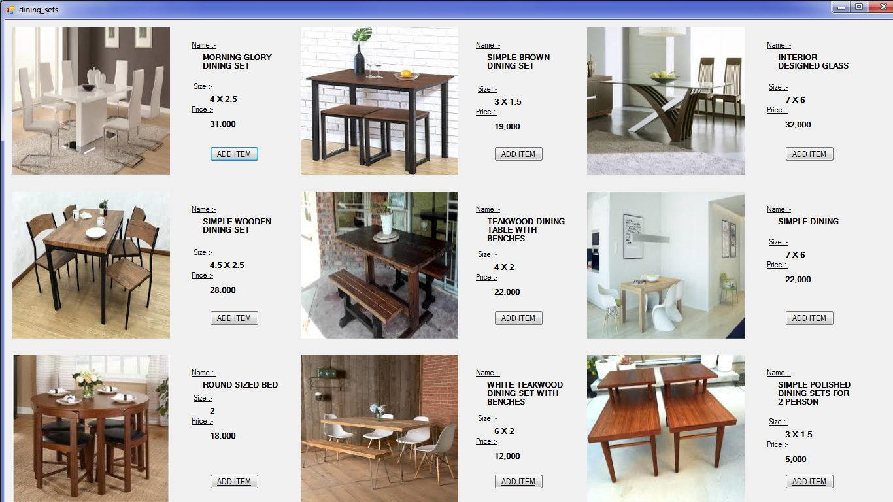

* This is Dining Sets design form.
* There are 9 different designs of Dining Sets.
* If you click on "ADD ITEM" , image will be added in the database.
* When you click on the "ADD ITEM" button button's name will be changed into "REMOVE".
* If you want to remove that item, item will be removed from the database.
* **Temple Design-**

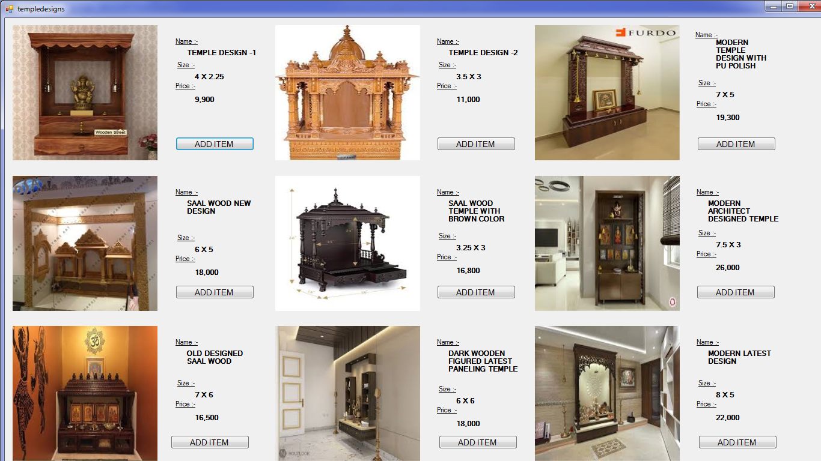

* This is Temple design form.
* There are 9 different designs of Temple.
* If you click on "ADD ITEM" , image will be added in the database.
* When you click on the "ADD ITEM" button button's name will be changed into "REMOVE".
* If you want to remove that item, item will be removed from the database.
* **TV Unit Design-**

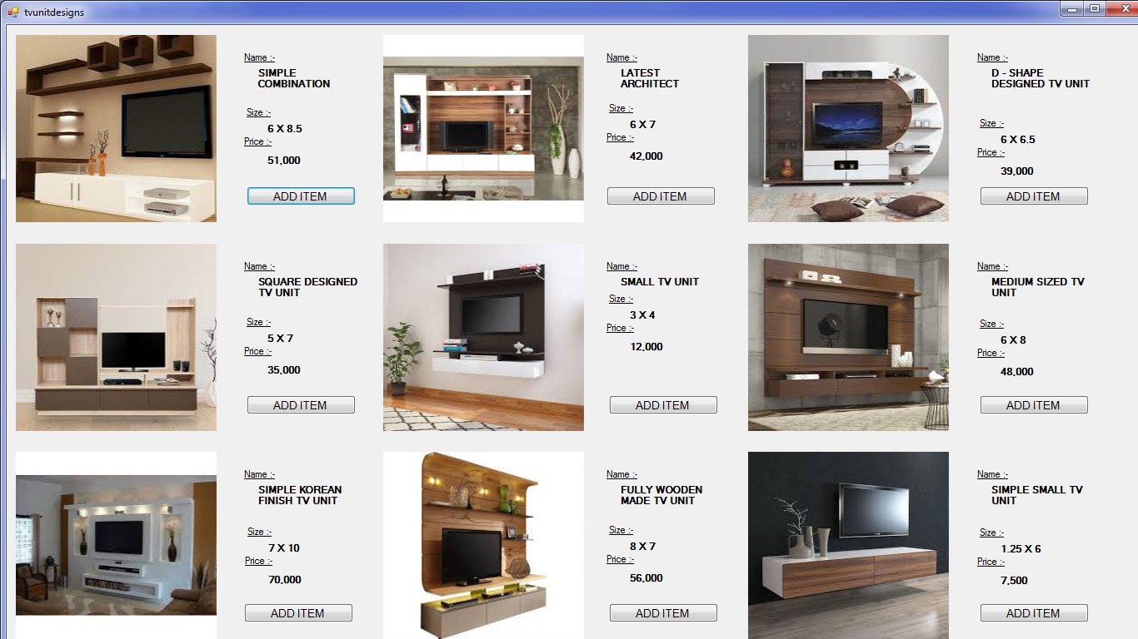

* This is TV Unit design form.
* There are 9 different designs of TV Unit.
* If you click on "ADD ITEM" , image will be added in the database.
* When you click on the "ADD ITEM" button button's name will be changed into "REMOVE".
* If you want to remove that item, item will be removed from the database.
* **Tipoi Design-**



* This is Tipoi design form.
* There are 9 different designs of Tipoi.
* If you click on "ADD ITEM" , image will be added in the database.
* When you click on the "ADD ITEM" button button's name will be changed into "REMOVE".
* If you want to remove that item, item will be removed from the database.
* **Wall Design-**

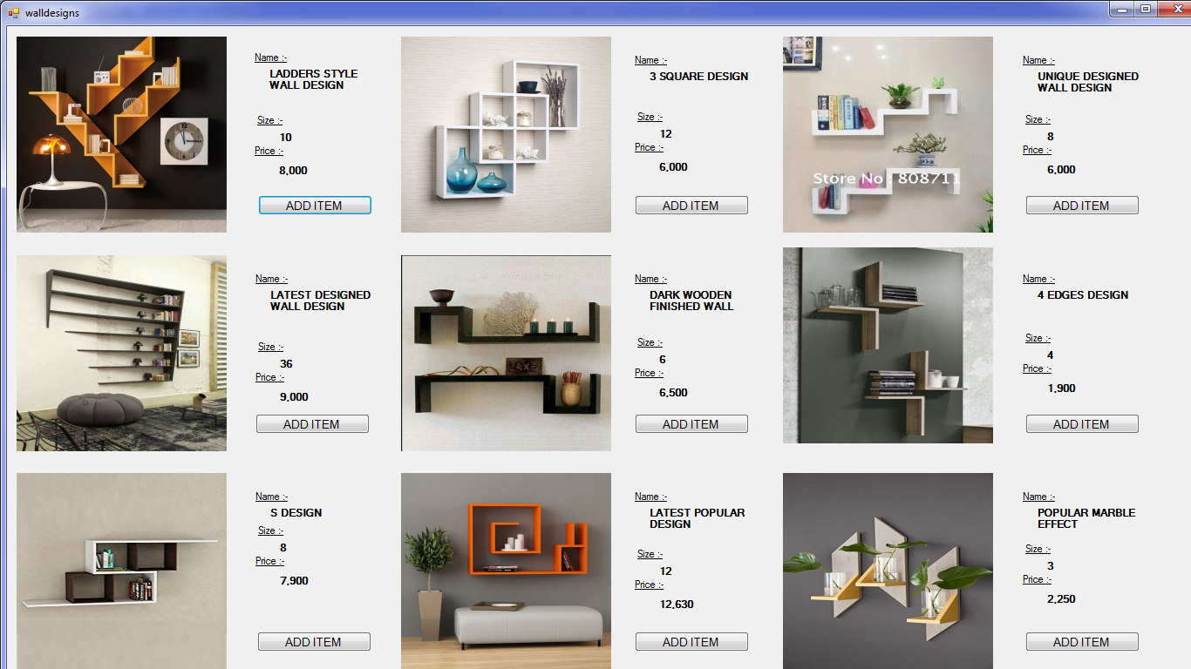

* This is Wall design form.
* There are 9 different designs of Wall.
* If you click on "ADD ITEM" , image will be added in the database.
* When you click on the "ADD ITEM" button button's name will be changed into "REMOVE".
* If you want to remove that item, item will be removed from the database.
* **Shoe Rack Design-**

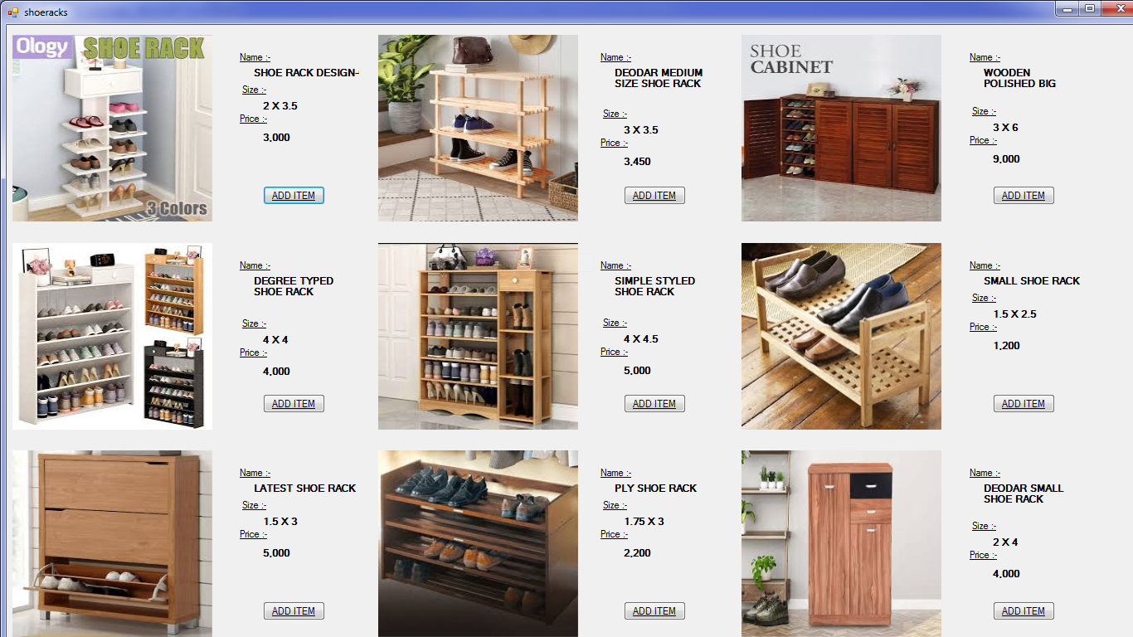

* This is Shoe Rack design form.
* There are 9 different designs of Shoe Rack.
* If you click on "ADD ITEM" , image will be added in the database.
* When you click on the "ADD ITEM" button button's name will be changed into "REMOVE".
* If you want to remove that item, item will be removed from the database.
* **Study Table Design-**

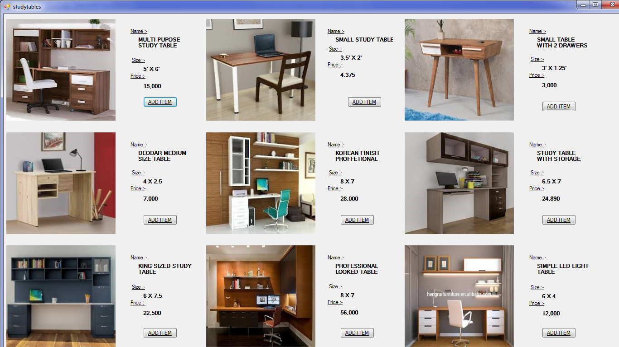

* This is Study Table design form.
* There are 9 different designs of Study Table.
* If you click on "ADD ITEM" , image will be added in the database.
* When you click on the "ADD ITEM" button button's name will be changed into "REMOVE".
* If you want to remove that item, item will be removed from the database.
* **Bill Page Design-**

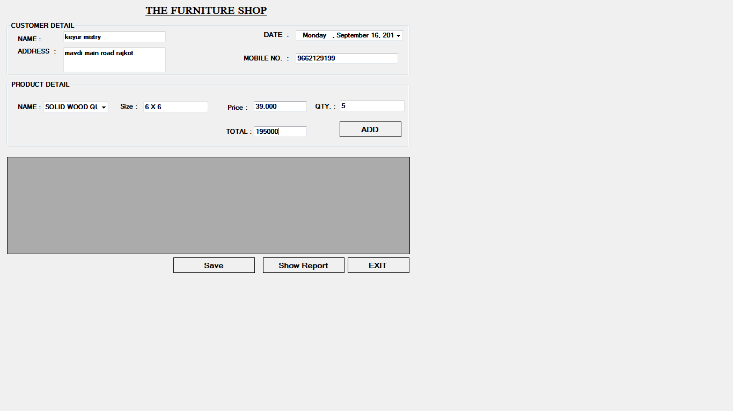

* This is Bill Page design form.
* Bill will be generated in this form.
* In this form, customer detail, product details, etc. are included.
* **Crystal Report Design-**

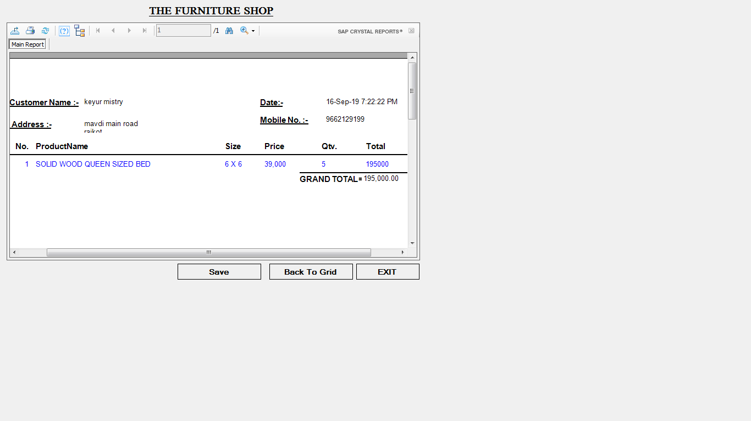

* This is Crystal Report design form.
* Crystal report will be generated in this form.

**Future Requirement of Project**

* We will try to remove all the bugs which is harmful For our application and add new features with user Friendly design in future.
* So we try our best to project more effective & give the batter facility.

# **LIMITATIONS OF PROJECT**

# Probability of to crash application depends on windows configurations.

# Have to take database backup for to reduce lost data in our computer.

# **BIBLOGRAPHY**

# **Reference Book**

# Introduction to .Net framework ==Work publication.

# **Microsoft ADO.Net ============Rebecca M.**

# Website

# [www.stackoverflow.com](http://www.stackoverflow.com)

# www.c#corner.com